**Tareas a realizar**

1. Write a method in Java to get the difference between the largest and smallest values in an array of integers. The length of the array must be 1 and above.
2. Write a method in Java to find the smallest and second smallest elements of a given array and print it in the console.
3. Write a method in Java that resolves this mathematical expression where x and y are two variables pre-set in your code.

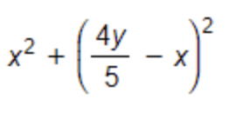

1. Compartirlo con los instructores y compañeros